Software Requirements Specification
for
NovaMail Firefox Extension
Version 1.1 approved
Prepared by Kory Kirk, Andrew Chickadel & John McCoey
CSC 4700
4/28/08
Table of Contents
Table of Contents ii
Revision History ii
1. Introduction 1
1.1 Purpose 1
1.2 Document Conventions 1
1.3 Intended Audience and Reading Suggestions 1
1.4 Product Scope 1
1.5 References 1
2. Overall Description 1
2.1 Product Perspective 1
2.2 Product Functions 2
2.3 User Classes and Characteristics 2
2.4 Operating Environment 2
2.5 Design and Implementation Constraints 2
2.6 User Documentation 2
2.7 Assumptions and Dependencies 2
3. External Interface Requirements 2
3.1 User Interfaces 2
3.2 Hardware Interfaces 2
3.3 Software Interfaces 3
3.4 Communications Interfaces 3
4. System Features 3
4.1 Toolbar Indicator Button 3
4.2 Options Pane 4
4.3 Pop-up notification 4
5. Other Nonfunctional Requirements 5
5.1 Performance Requirements 5
5.2 Safety Requirements 5
5.3 Security Requirements 5
5.4 Software Quality Attributes 5
Appendix A: Glossary 5
Appendix B: Graphical User Interface 6
Appendix C: UML Diagrams 6

Revision History
Name | Date | Reason For Changes | Version
Chickadel, McCoey, Kirk | 3/28/08 | Initial Creation of Software Specification | 1.0
Chickadel, McCoey, Kirk | 4/28/08 | Software Specification Revision with Visuals | 1.1

Introduction

Purpose

The Villanova Email FireFox Extension informs users, who have the web browser open, when they receive a Villanova E-Mail. This allows for users to avoid the tedious task of checking their Villanova web mail to know whether or not they have new emails.

Document Conventions
The Villanova Email Firefox Extension will be referred to as NovaMail.

Intended Audience and Reading Suggestions
The intended user is a Villanova Student/Faculty/Staff with a Villanova e-mail account and the Mozilla FireFox web browser.

Product Scope
Using this extension helps save time because users will not have to continually log in and check their e-mail. This also improves users’ efficiency in responding to potentially important e-mail messages with greater speed.

References
The NovaMail development webpage is located at http://www.whileyouwereafk.com. References to the Firefox browser which this extension is built for can be found at http://www.mozilla.org.

Overall Description

Product Perspective
The NovaMail Firefox Extension is an add-on to the Mozilla Firefox web browser. Firefox is an open source, completely customizable web browser. This browser can be downloaded to any computer for free, and then customized with extensions such as NovaMail. The only requirements for a NovaMail Firefox Extension on a computer are the existence of the Firefox web browser with internet access as well as a Villanova email address and password.

Product Functions
The NovaMail Firefox Extension allows users to:
- Save a Villanova username and password
- Be notified of new messages in their Villanova inbox
- Be re-directed directly to the inbox without logging in.

User Classes and Characteristics
The NovaMail Extension is aimed for students, faculty, and staff of Villanova University who use the Firefox browser. Anyone who can access a Villanova Webmail account with a username and password can download and install the extension to monitor their emails.

Operating Environment
The only software requirement for the NovaMail Extension is access to a computer with Firefox installed and access to the internet. Firefox can be installed on any operating system, including Windows, Mac OS, and Linux.

Design and Implementation Constraints
The NovaMail Extension user assumes any and all responsibility for the use, installation, and removal of the NovaMail software. As is, the extension will work as long as the Villanova Webmail server is up and running. NovaMail is free to download and all of the code will be completely open source, allowing the user to view and edit the code.

User Documentation
User documentation can be found at http://www.whileyouwereafk.com. Help for the Firefox web browser can be found at http://www.mozilla.org.

Assumptions and Dependencies
The NovaMail Firefox Extension assumes the Villanova Webmail server is functional.

External Interface Requirements

User Interfaces
The NovaMail Firefox extension places a button on the browser toolbar which displays “0 new messages.” The user must save their username and password on the first start up in order to log in to Villanova web mail and receive the number of new messages. At this time, the Button will display a Login image of a Villanova V with a key. Your username and password is saved in the options, which can be accessed and changed by going through FireFox’s Tools > Add-ons menu, and then clicking options on the NovaMail extension. When a new message is found in the inbox, the button’s image changes from a Villanova V to a V with a picture of a small envelope. In the status bar, the text changes to read “1 new message” and a pop-up is displayed along with an accompanying notification sound. If another message is found before the user checks their email, NovaMail will increase the number by 1 for each new message, therefore showing a total of all the new messages since the user last read his or her email. The button can then be clicked to open the user’s inbox in a new tab. This resets the counter to zero and allows the user to read their email as they normally would with Villanova web mail. If no internet connection is available, The V will go gray and show a red X and display “Connection Error” in the status bar.

Hardware Interfaces
The only hardware interface required is a basic knowledge of a keyboard and mouse in relation to the specific computer’s operating system and Mozilla Firefox.

Software Interfaces
This extension requires only the installation of Mozilla Firefox as the user’s web browser and the download and installation of the NovaMail extension.

Communications Interfaces
NovaMail requires access to the internet in order to send requests which return the number of new messages. This action takes place behind the scenes in regards to the user, and requires only the use of basic HTTP communication through the internet with Villanova Webmail.

System Features
This template illustrates organizing the functional requirements for the product by system features, the major services provided by the product. You may prefer to organize this section by use case, mode of operation, user class, object class, functional hierarchy, or combinations of these, whatever makes the most logical sense for your product.>

  - Toolbar Indicator Button

    - Description
The toolbar indicator button is situated on the FireFox toolbar which is typically located just under the address bar. This toolbar indicator button displays to users how many new messages are currently in their Villanova E-mail Inbox. This notification appears in the form: “New Messages: #”. The button provides a direct link to the user’s e-mail inbox.

    - Stimulus/Response Sequences
Notifications require no user input or action. When the user clicks the button, his or her e-mail inbox is displayed instantly in a new FireFox tab.

    - Functional Requirements
REQ-1: The number of new e-mail messages must be stored internally in the program and displayed on the indicator button.
REQ-2: If the user is not already authenticated to the e-mail system, he or she will be directed to enter the necessary log-in information.
REQ-3: If there are no new e-mail messages, the button’s functionality will be disabled.
REQ-4: If there is a server or connection error, the user will be prompted to check the connection or to try again later.

  - Options Pane

    - Description and Priority
The options pane serves primarily as the input for the user’s log-in information, specifically, the username and password for authentication to the e-mail system. Information need only be entered once, during the first ever use of the ‘NovaMail extension, unless the username and/or password changes. The options pane also allows the user to enable or disable sound (.WAV) or pop-up notification.

    - Stimulus/Response Sequences
When the user correctly types his or her log-in information, he or she will be authenticated to the e-mail system. If the user checks the checkbox labeled “Sound Enabled”, sound notifications will be enabled. Leaving the box unchecked will disable all ‘NovaMail sounds. Similarly, if the user checks the “Pop-up Notification Enabled” checkbox, pop-ups will be enabled. Pressing the “Cancel” button does not save any newly changed options.

    - Functional Requirements
REQ-1: The username and password entered by the user must be able to be passed directly into the e-mail authentication system.
REQ-2: If one or both of the user entries are not correct, the user will be directed to re-enter the required information.
REQ-3: If the authentication cannot be completed due to a network error, the user will be prompted to re-try or to check the network status.
REQ-4: The “password” entry field on the options pane must be a secure entry field, preventing the password from being read from the screen.

  - Pop-up Notification

    - Description and Priority
Pop-up notification alerts users when new mail arrives in their inbox via a small pane in the lower right-hand corner of the screen. There is a link to the user’s inbox embedded within the pop-up. The pop-up will display the text “You have # new messages!” or “You have 1 new message!”

    - Stimulus/Response Sequences
No user input or action is required for the pop-up functionality. When the user clicks on the pop-up pane, his or her inbox will be displayed in a new FireFox tab, similarly to clicking the indicator button.

    - Functional Requirements
REQ-1: The pop-up notification will use the same numerical new message value as the indicator button.
REQ-2: The pop-up must contain an embedded link that displays the user’s inbox in a new FireFox tab when the pop-up is clicked.
REQ-3: If there is a server or connection error, the user will be prompted to check the connection or to try again later.

Other Nonfunctional Requirements

Performance Requirements
NovaMail can run on any computer system that can run the Firefox web browser. To see the system requirements for Firefox, please visit http://www.mozilla.com/en-US/firefox/system-requirements.

Safety Requirements
There are no safety requirements.

Security Requirements
NovaMail should be used on a closed and encrypted network. If the network is not encrypted and closed, the user’s login information is potentially vulnerable to interception. This risk does not originate from our program, but rather it exists in the web mail login process for all users regardless of whether or not they are using NovaMail. NovaMail runs the same security risks as the Mozilla Firefox web browser. NovaMail has the same security risks as logging into your Villanova Webmail.

Software Quality Attributes
The product is licensed under the GPL. Therefore anyone may add to it or edit it. NovaMail can be used the same on any computer with a Firefox browser, after a quick download. NovaMail comes in .xpi (zippy) file format, which has the same file attributes as a .zip file. The source code is located directly in that zip file, and can be changed by anyone, as long as that modified code is released under the GPL. For more information on the GPL please visit http://www.gnu.org/copyleft/gpl.html

Appendix A: Glossary
Firefox – Mozilla Firefox Browser
NovaMail – Villanova Email Firefox Plugin
Appendix B: Graphical User Interface

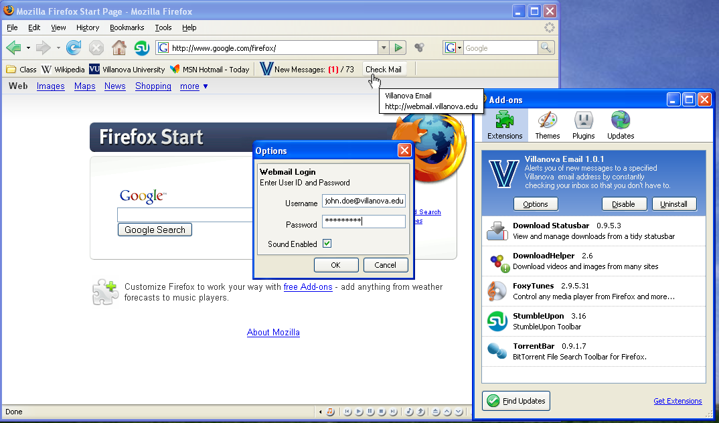

Figure 1: NovaMail preferences and normal state

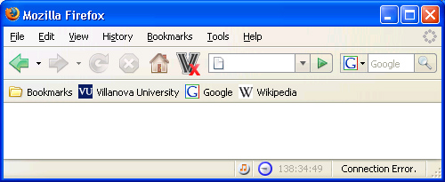

Figure 2: Connection Error

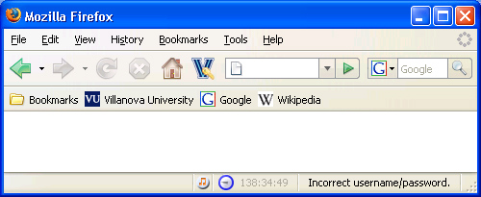

Figure 3: Login
Appendix C: UML Diagrams

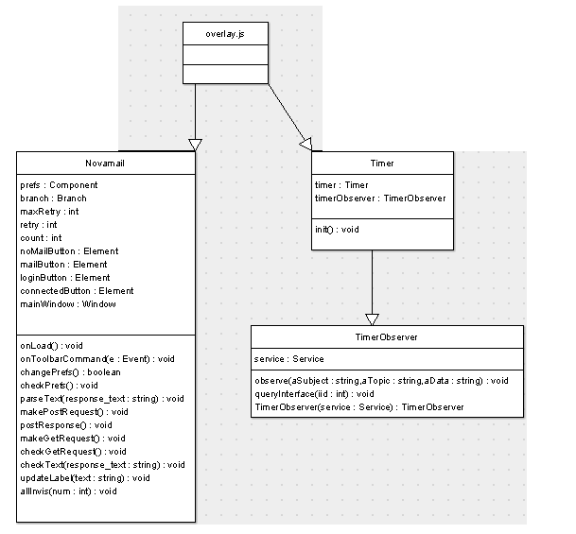

Overlay UML
This is the diagram for the back end of the extension, written in Javascript

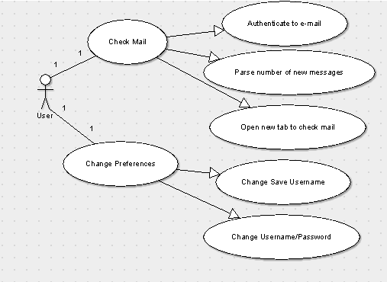

This is the UML diagram for how the User interacts with the Firefox extension and what the extension does for each user action.

